cS557 Project #6

Ritesh Sharma

MS Student, Computer Science,

Oregon State University

GLSL is such a powerful shading language which can generate image in a fly. It’s been fun generating images by writing very few lines of code.

For this project, I have used hints given in project description and some codes provided during the class lecture. The main task of this project was to create a “Magic Lens”. In computer graphics (and especially in visualization), there is a technique called a Magic Lens. A Magic Lens is some shape, usually a rectangle or circle, in which a different version of the display is drawn.

In order to get the magnification effect, we needed to take the part of an image and multiply it by the magnification factor and display. To do such effect, I first created an area which is rectangle if **uCircle** is not selected in the GUI. This area was based on the center coordinate of the image. To display, I have to check whether the area magnified is inside the rectangle or circle was based on the equation of circle in case of circle and for rectangle we check for the pixel lying inside the rectangle.

To create rectangle, I used the following code,

*float top = uScenter + uDs;*

*float bottom = uScenter - uDs;*

*float right = uTcenter + uDt;*

*float left = uTcenter - uDt;*

For magnification, following code is being used:

s = s - uScenter;

t = t - uTcenter;

s = s * 1.0 / uMagFactor;

t = t * 1.0 / uMagFactor;

The choice of image which I made is one of the Seven Wonders of the World which is in my country, India.

The original image is given below:

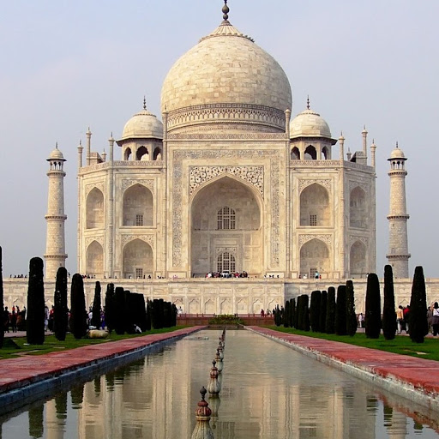

**Figure 1. Original Image**

Resultant image is as follows:

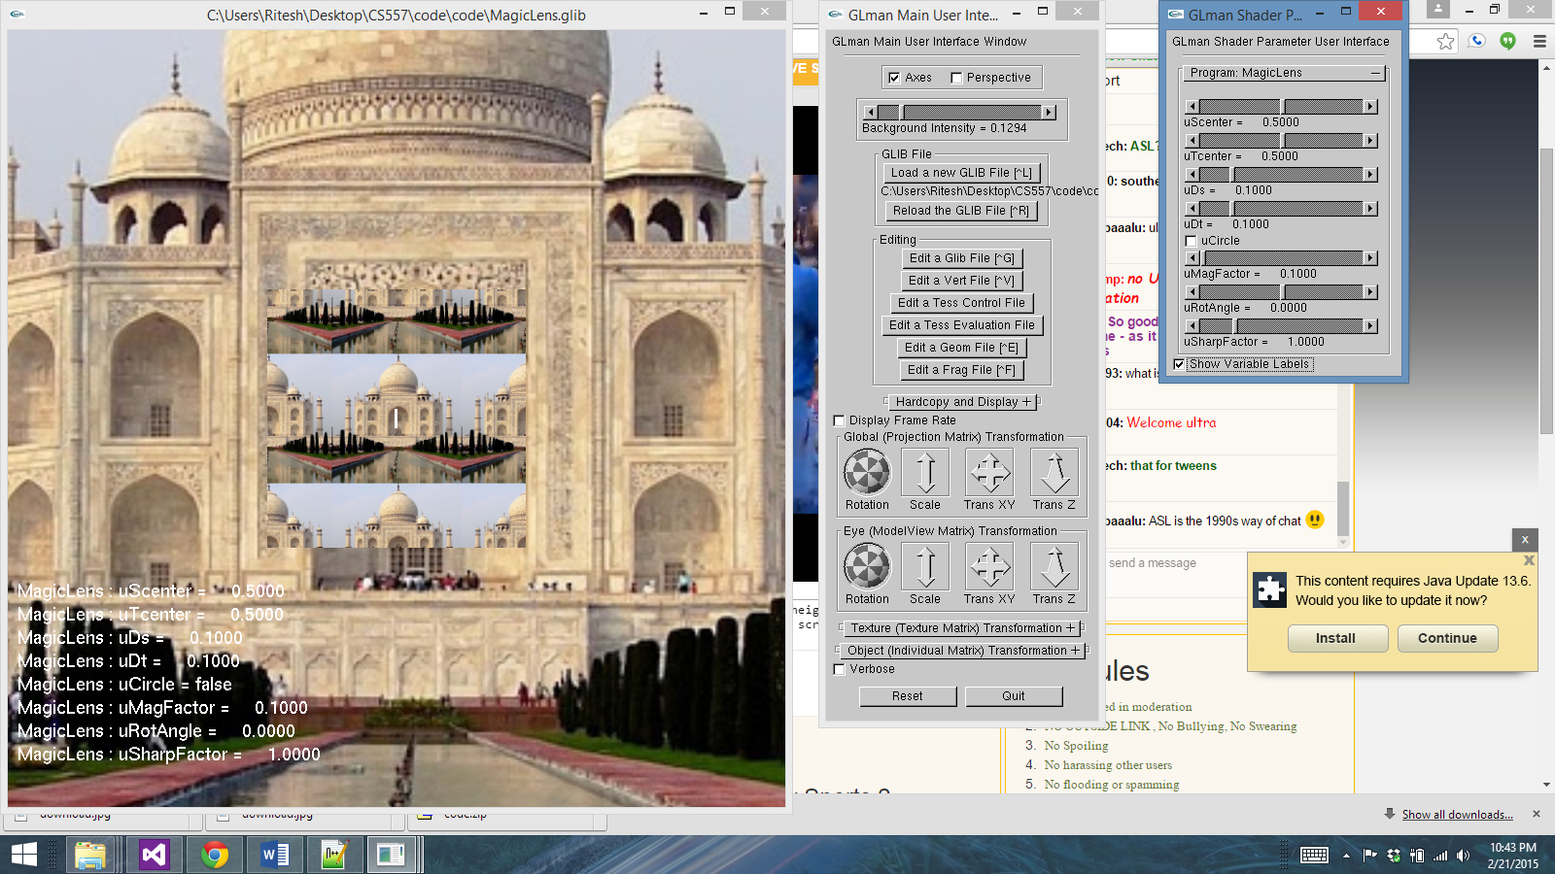

**Figure 2. Resultant Image with when magnification is less than 1**

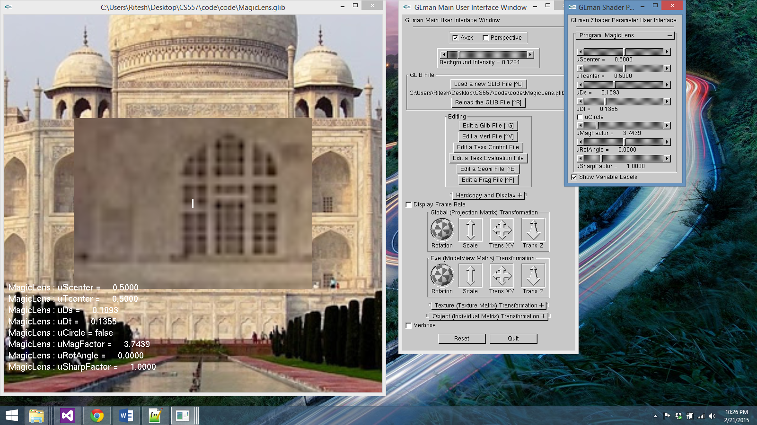

**Figure 3. Resultant Image with rectangular Magic Lens with length 0.135 and breadth 0.1893**

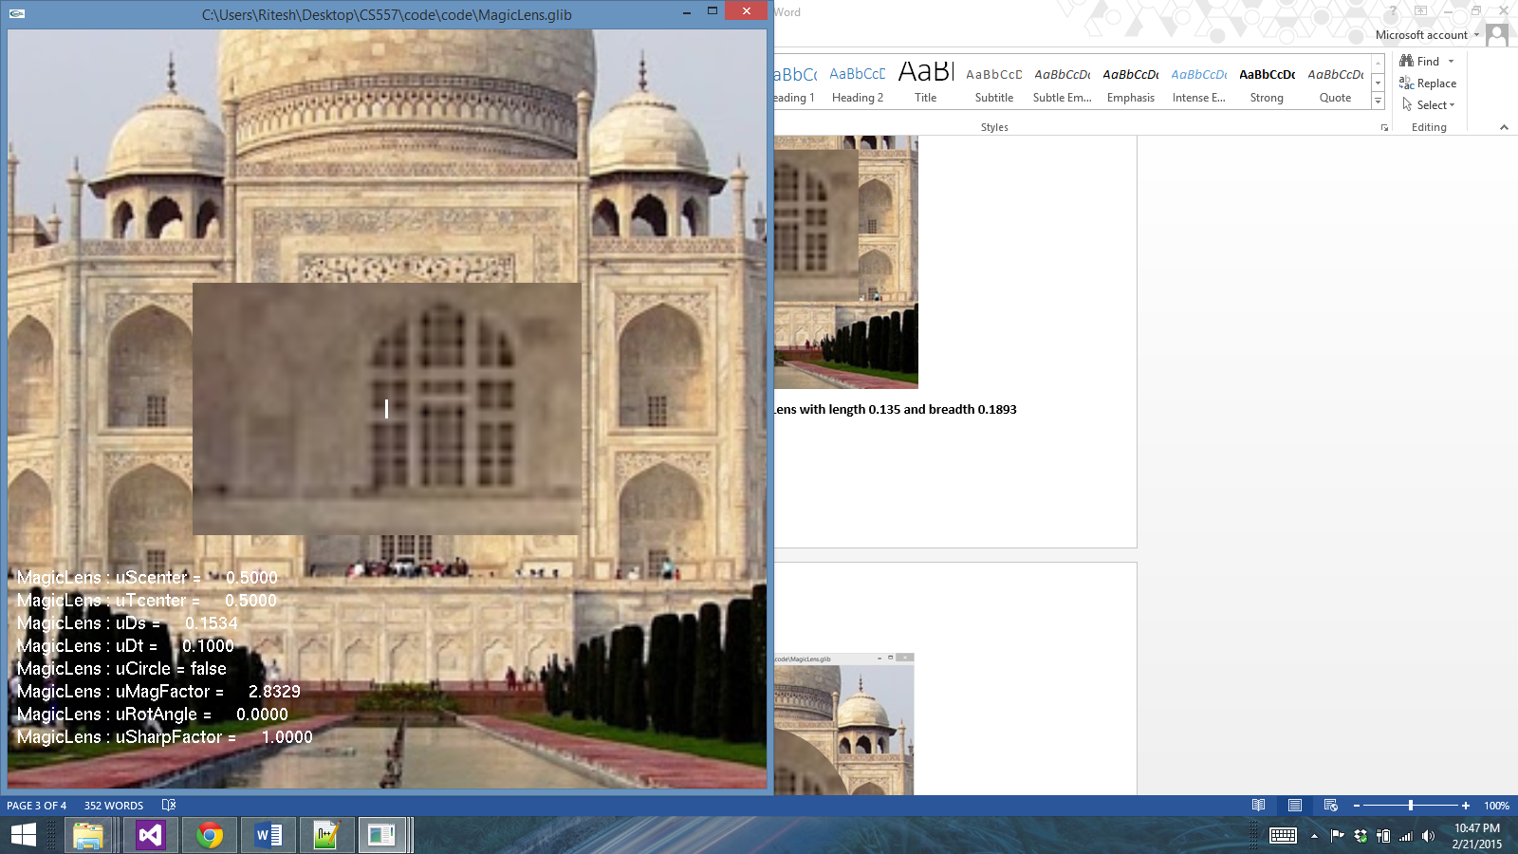

**Figure 4. Resultant Image with rectangular Magic Lens with length 0.15 and breadth 0.1**

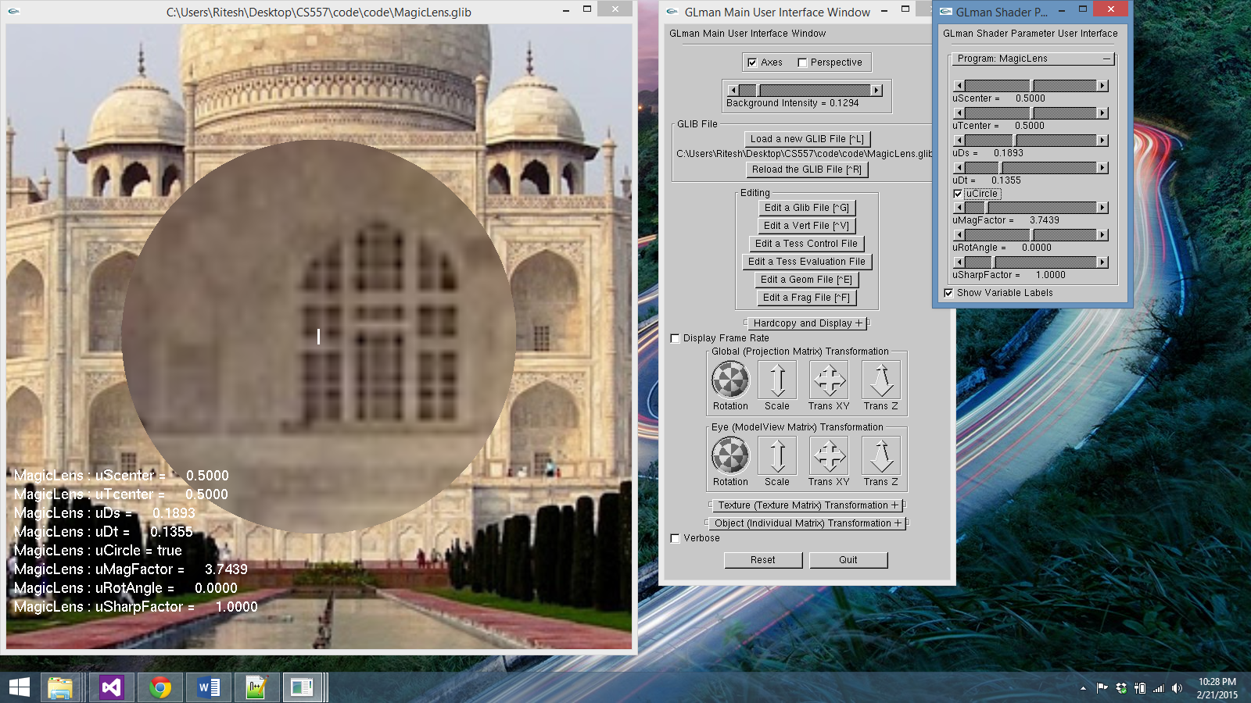

**Figure 5. Resultant Image with circular Magic Lens**

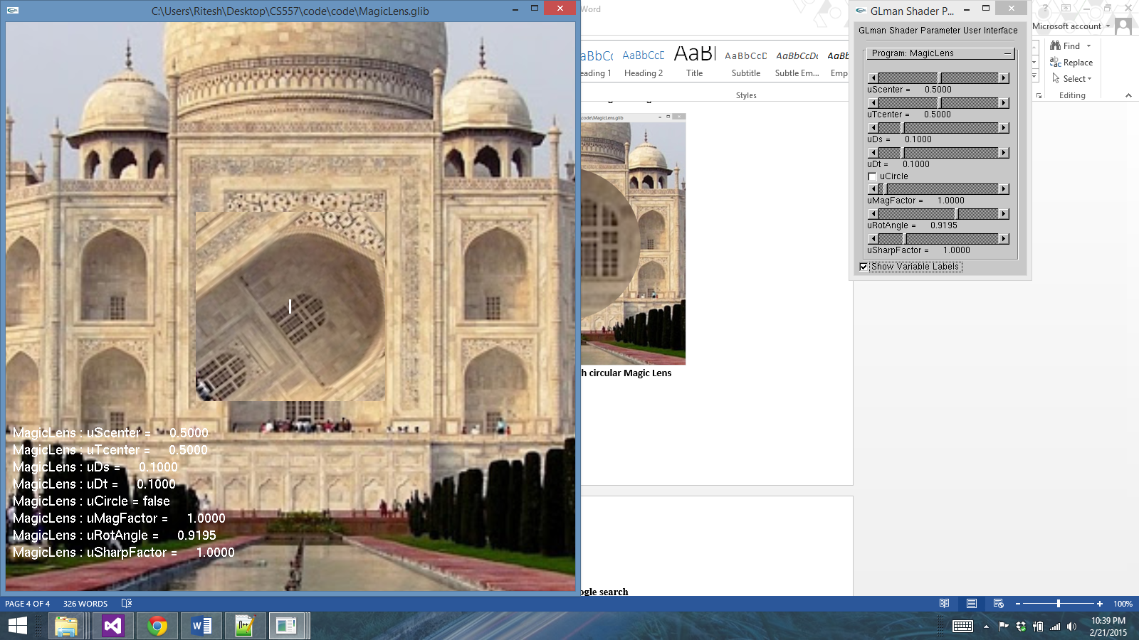

**Figure 6. Resultant Image with rotated circular Magic Lens**

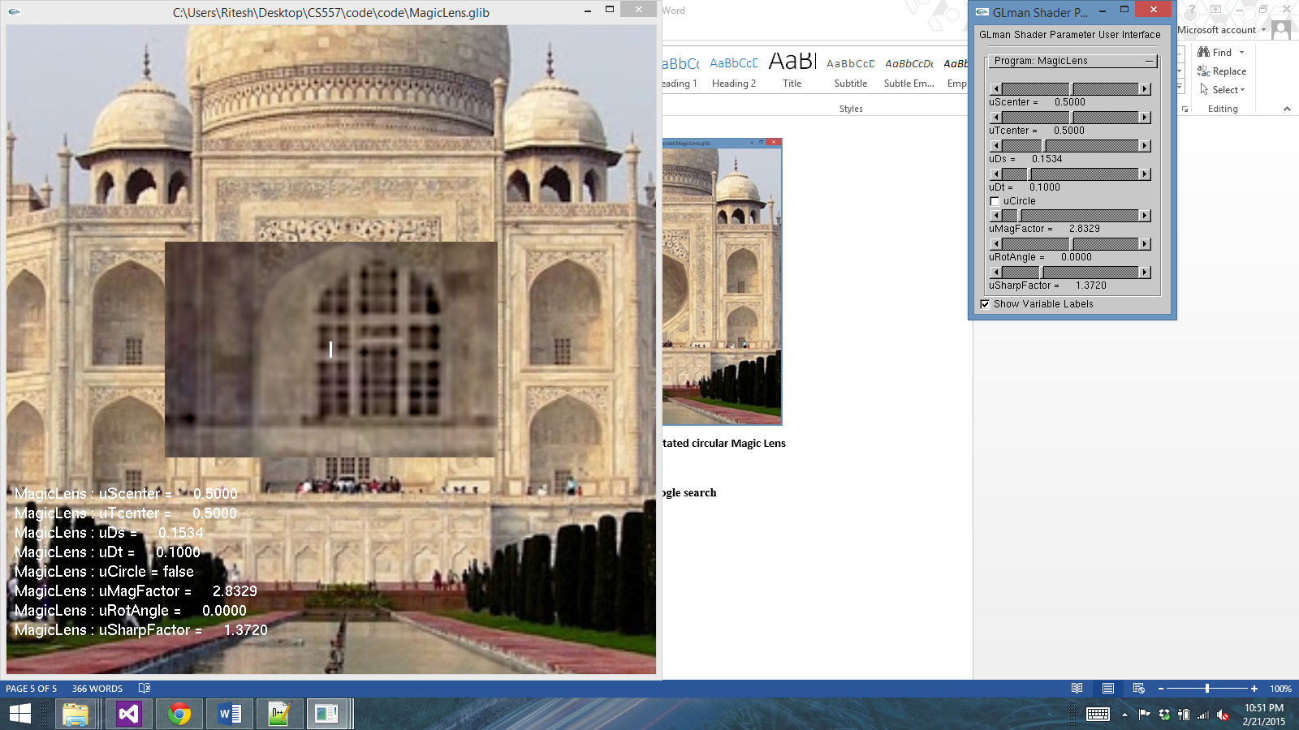

**Figure 7. Resultant Image with sharpeninng factor=1.3720**

**Note: Image has been taken from internet through google search**